**Practical-1**

**AIM: Usage of cables and channels in various types of networks.**

--------------------------------------------------------------------------------------------------------------------------------------

Refer these links for better understanding of the same:

1. <https://www.wikihow.com/Create-an-Ethernet-Cable>
2. https://www.cnet.com/how-to/how-to-make-your-own-ethernet-cable/
3. <https://www.ertyu.org/steven_nikkel/ethernetcables.html>
4. <https://www.youtube.com/watch?v=lullzS740wI&t=148s>
5. <https://www.youtube.com/watch?v=NmtMPSu--q0>
6. **Cabling:** <https://www.youtube.com/watch?v=KfhVrivvL7E&list=PLcxPetO_cDzvtZpI-zjKKsc1LZ7K_fDuC&index=14>
7. **Crossover cable:** <https://www.youtube.com/watch?v=Xc4fWgNDniQ&list=PLcxPetO_cDzvtZpI-zjKKsc1LZ7K_fDuC&index=15>
8. **UTP Vs STP:**  <https://www.youtube.com/watch?v=4cgzuvaukVY&list=PLEWX0h0oWdl0GcSwE3Cs_Uz-EgKVe84Fn>

**Submission**: After writing an answer into this word document, Student needs to change name to his ID followed by practical number. Ex 21ce005_Pr1.docx. Upload on assignment segment. Take the speed as your student ID. Ex. 21ce005, speed would be 5 Mbps.

**Rubrics**: Nicely drafted document with clarity in answers leads to full marks. Otherwise, submission carries proportional marks.

--------------------------------------------------------------------------------------------------------------------------------------

**Refer the following Transmission Modes - Modes of Communication and based on that perform the following case study and write down proper answers of it.**

In **Scenario - 1,** as shown in figure 1.1,Let’s assume that a car (4-seater Inline) with the constant speed of 60Km/h issues a ticket from the Toll booth to go to its destination. Before the destination there is another Toll Booth which checks the ticket of the car. There is a 120km one way road of 120Km between the two Toll Booths. (Simplex)

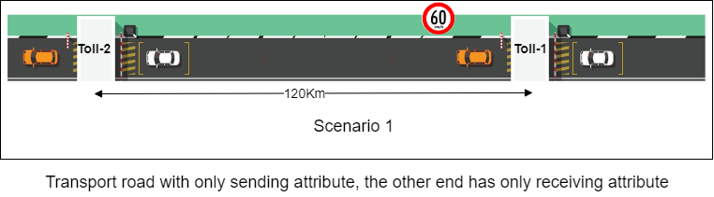

Figure 1.1 Scenario 1

Analogy with computer network

Table 1.2 Simplex Communication

|  |  |  |
| --- | --- | --- |
| **Parameters** | **Road Transport** | **Network** |
| **Distance** | Road Length 120KM | Length of Wire/Channel  120KM |
| **Direction** | **One Way**  ( Either way  Both the way ) | **Simplex**  ( Half Duplex  Full Duplex ) |
| **Speed** | Car speed 60 km/hr | Link Speed 2.8*108m/s  (10 Mbps) |
| **Toll Booth-1** | Toll point issue tickets | Transmission Hardware (NIC Card) |
| **Toll Booth-2** | Toll point checks tickets | Receiving Hardware (NIC Card) |
| **Time to reach from Toll-1 to Toll-2** | 2 Hours | 428.6 ms |
| **Road** | Damar Road | Channel (Signal carries data) |
| **Number of Lane/Road** | **Single Lane**  ( Multiple Lane ) | **Single Channel**  ( Multiple Channel ) |
| **Injection** | Number of Passengers in Car: 4, they seat back-to-back. | Number of chunks /signals /data |
| **number of deck on car** | **Single car**  ( Double Decker Car ) | **Without Multiplexing**\*  ( With multiplexing ) |

*Multiplexing: combining together

In **Scenario - 2,** as shown in figure 1.2,Let’s assume that a car (4-seater Inline) with the constant speed of 60Km/h issues a ticket from the Toll booth to go to its destination. Before the destination there is another Toll Booth which checks the ticket of the car. Both the Stations are connected with a single one-way bridge. (Half Duplex)

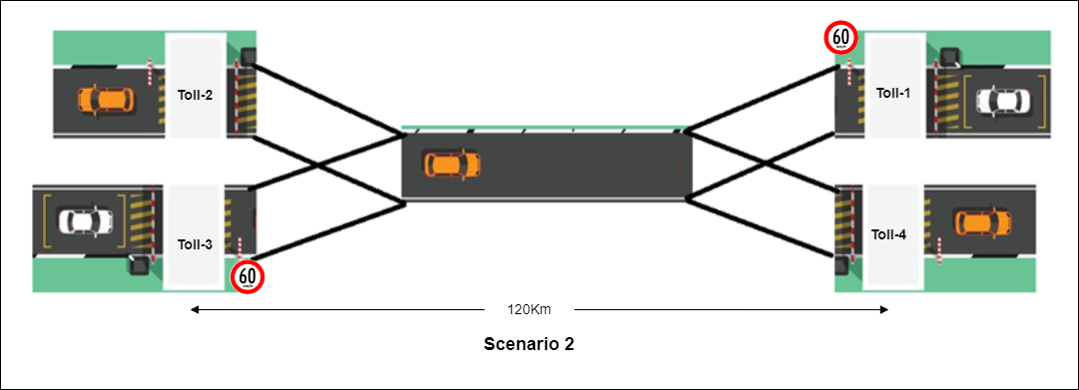

Figure 1.2 Scenario 2

**Analogy with computer network: Fill the rows**

Table 1.2 Half Duplex Communication

|  |  |  |
| --- | --- | --- |
| **Parameters** | **Road Transport** | **Network** |
| **Distance** | Road Length 120KM | Length of Wire/Channel  120KM |
| **Direction** | ( Either way) | ( Half Duplex) |
| **Speed** | Car speed 60 km/hr | Link Speed 2.8*108m/s  (10 Mbps) |
| **Toll Booth-1** | Toll point issue tickets | Transmission Hardware (NIC Card) |
| **Toll Booth-2** | Toll point checks tickets | Receiving Hardware (NIC Card) |
| **Toll Booth-3** | Toll point issue tickets | Transmission Hardware (NIC Card) |
| **Toll Booth-4** | Toll point checks tickets | Receiving Hardware (NIC Card) |
| **Time to reach from Toll-1 to Toll-2** | 2 Hours | 428.6 ms |
| **Road** | Damar Road | Channel (Signal carries data) |
| **Number of Lane/Road** | **Single Lane** | **Single Channel** |
| **Injection** | Number of Passengers in Car: 4, they seat back-to-back. | Number of chunks /signals /data |
| **number of deck on car** | **Single car** | **Without Multiplexing**\* |

In **Scenario - 3,** as shown in figure 1.3, Let’s assume that a car (4 seater Inline) with the constant speed of 60Km/h issuing a ticket from the Toll booth to go to its destination. Before the destination there is another Toll Booth which checks the ticket of the car. There is a two way road of 120Km between the two Toll Booths. One road to go from toll-1 to toll-2 and second is to go from toll-3 to toll-4. (Full duplex)

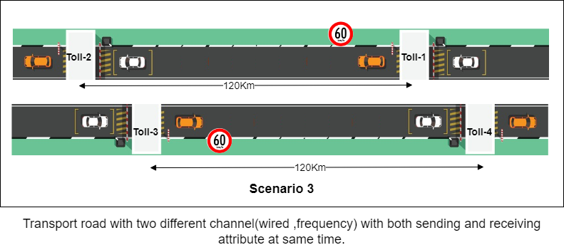

Figure 1.3 Scenario 3

**Analogy with computer network: Fill the rows**

Table 1.3 Full Duplex Communication

|  |  |  |
| --- | --- | --- |
| **Parameters** | **Road Transport** | **Network** |
| **Distance** | Road Length 120KM | Length of Wire/Channel  120KM |
| **Direction** | ( Both way) | (full Duplex) |
| **Speed** | Car speed 60 km/hr | Link Speed 2.8*108m/s  (10 Mbps) |
| **Toll Booth-1** | Toll point issue tickets | Transmission Hardware (NIC Card) |
| **Toll Booth-2** | Toll point checks tickets | Receiving Hardware (NIC Card) |
| **Toll Booth-3** | Toll point issue tickets | Transmission Hardware (NIC Card) |
| **Toll Booth-4** | Toll point checks tickets | Receiving Hardware (NIC Card) |
| **Time to reach from Toll-1 to Toll-2** | 2 Hours | 428.6 ms |
| **Time to reach from Toll-3 to Toll-4** | 2 Hours | 428.6 ms |
| **Road** | Damar Road | Channel (Signal carries data) |
| **Width of Lane/Road** | Single lane | Single Channel |
| **Number of Lane/Road** | Two | Multiple Channel |
| **Injection** | Number of Passengers in Car: 4, they seat back-to-back. | Number of chunks /signals /data |
| **Number of deck on car** | **Single car** | **Without Multiplexing**\* |

**Simplex:**

* Simplex channel operation
* one way only
* one person talks and other listens

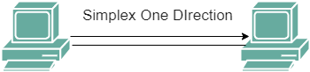

**Half Duplex:**

* Two-way communication
* Two people can talk but one at a time



**Full Duplex:**

* Both ways of communication.
* Two people can talk simultaneously.



**Exercise:** Calculate the cost of the Network 100 metre network of 2 Machines. Also write a list of equipment required for each type and medium of network.

Table 1.4 Exercise

|  | **Wired** | **Wireless** | **Fiber Optic Cable** |
| --- | --- | --- | --- |
| **Simplex** | Keyboard ,mouse | Wifi router |  |
| **Half Duplex** | Ethernet Cable | Bluetooth , talkie |  |
| **Full Duplex** | USB port | Video conference |  |

In **Scenario - 4,** Let’s assume that a car (4-seater Inline) with the constant speed of 60Km/h issues a ticket from the Toll booth to go to its destination. Before the destination there is another Toll Booth which checks the ticket of the car. There are two lane roads to go from Toll-1 to Toll-2 and Toll-3 to Toll-4. By Two roads the capacity of the road increases the number of cars which can travel through. (Full Duplex with Improved bandwidth)

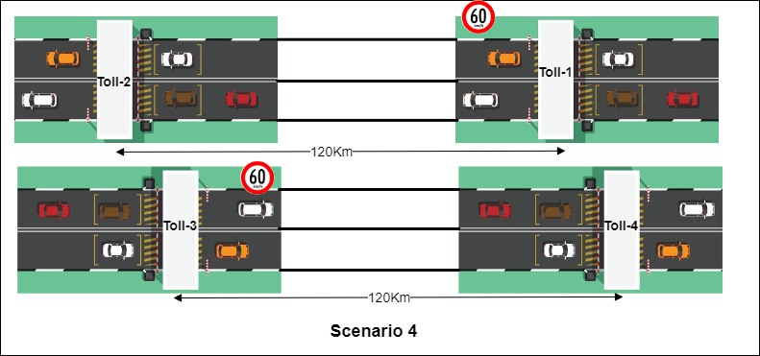

Figure 1.4 Scenario 4

**Analogy with computer network**

Table 1.5 Full Duplex with Improved bandwidth Communication

|  |  |  |
| --- | --- | --- |
| **Parameters** | **Road Transport** | **Network** |
| **Distance** | Road Length 120KM | Length of Wire/Channel  120KM |
| **Direction** | ( Both way) | (full Duplex) |
| **Speed** | Car speed 60 km/hr | Link Speed 2.8*108m/s  (10 Mbps) |
| **Toll Booth-1** | Toll point issue tickets | Transmission Hardware (NIC Card) |
| **Toll Booth-2** | Toll point checks tickets | Receiving Hardware (NIC Card) |
| **Toll Booth-3** | Toll point issue tickets | Transmission Hardware (NIC Card) |
| **Toll Booth-4** | Toll point checks tickets | Receiving Hardware (NIC Card) |
| **Time to reach from Toll-1 to Toll-2** | 2 Hours | 428.6 ms |
| **Time to reach from Toll-3 to Toll-4** | 2 Hours | 428.6 ms |
| **Road** | Damar Road | Channel (Signal carries data) |
| **Width of Lane/Road** | Double lane | Multiple Channel |
| **Number of Lane/Road** | Four | Multiple Channel |
| **Injection** | Number of Passengers in Car: 4, they seat back-to-back. | Number of chunks /signals /data |
| **Number of deck on car** | **Single car** | **Without Multiplexing**\* |

In **Scenario -5**, Let’s assume that a Double Decker car (4-seater Inline, 2 floors) with the constant speed of 60Km/h issuing a ticket from Toll booth to go to its destination. Before the destination there is another Toll Booth which checks the ticket of the car. Both the Stations are connected with a single one-way bridge. Only one double decker car can go through. **(Multiplexing)**

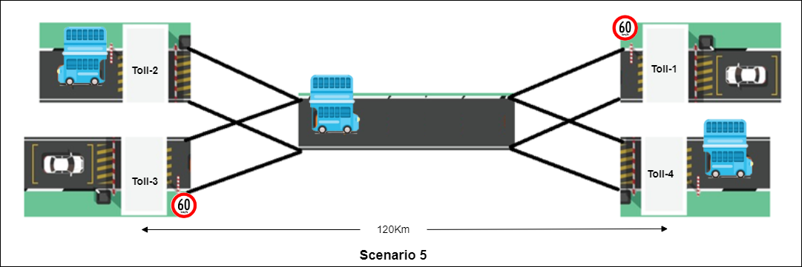

Figure 1.5 Scenario 5

Analogy with computer network: Fill the rows

Table 1.6 Multiplex Communication

|  |  |  |
| --- | --- | --- |
| **Parameters** | **Road Transport** | **Network** |
| **Distance** | Road Length 120KM | Length of Wire/Channel  120KM |
| **Direction** | (Either way) | (full Duplex) |
| **Speed** | Car speed 60 km/hr | Link Speed 2.8*108m/s  (10 Mbps) |
| **Toll Booth-1** | Toll point issue tickets | Transmission Hardware (NIC Card) |
| **Toll Booth-2** | Toll point checks tickets | Receiving Hardware (NIC Card) |
| **Toll Booth-3** | Toll point issue tickets | Transmission Hardware (NIC Card) |
| **Toll Booth-4** | Toll point checks tickets | Receiving Hardware (NIC Card) |
| **Time to reach from Toll-1 to Toll-2** | 2 Hours | 428.6 ms |
| **Time to reach from Toll-3 to Toll-4** | 2 Hours | 428.6 ms |
| **Road** | Damar Road | Channel (Signal carries data) |
| **Width of Lane/Road** | Single lane | Single Channel |
| **Number of Lane/Road** | Single | Single Channel |
| **Injection** | Number of Passengers in Car: 8, they seat back-to-back & up-down. | Number of chunks /signals /data |
| **Number of deck on car** | **Double deck car** | **With Multiplexing** |

**Scenario 6,** as shown in figure 1.6,Let’s say we want to travel from Ahmedabad to Surat. In this first we go through Express Highway till Vadodara after that we route for National Highway. Ahmedabad to Vadodara takes less time as cars can speed up to 100Km/h. Vadodara to Surat takes much time as cars can speed only up to 60Km/h. (Data Rate Changes with respect to link speed)

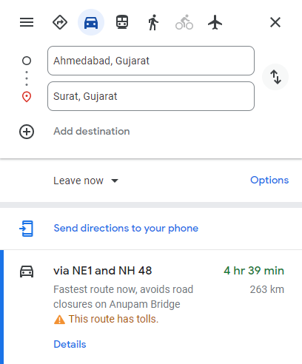 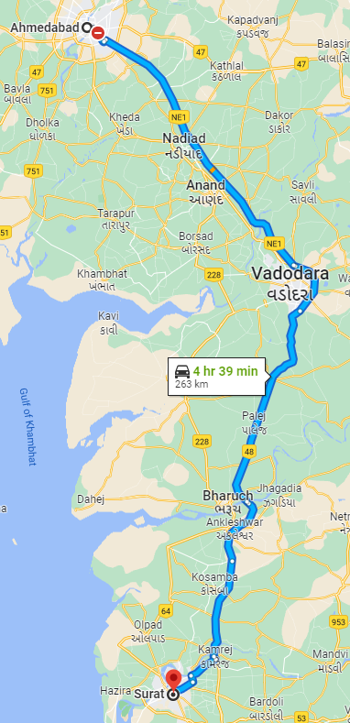

Figure 1.6 Different speed on different type of road

**Write conclusion with respect to computer networks:**

**Types of Delay:**

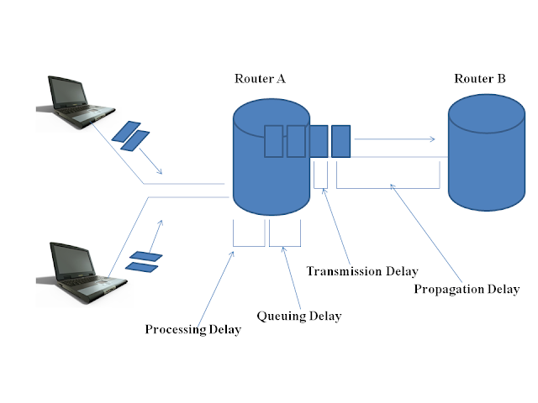

Figure 1.9 Scenario 5

In Scenario -1**,** different cars coming from each direction have to wait for the signal to cross the road as the road is busy because other cars are crossing through the same cross road.

**Exercise:** Write down transmission delay, queueing delay of computer network with respect to following cross road analogy.

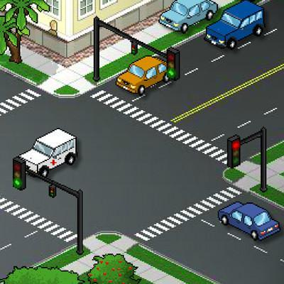

Figure 1.8 Scenario 5

**Case Study:**

**Refer to the following diagram and identify which mode of communication happens.**

1) Refer to the following two scenarios and identify which type of communication is done.

**Scenario 1:**  Can different radio stations work at the same time using the same frequency.

Ans:

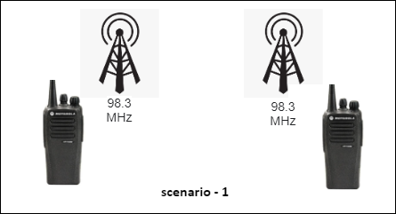

Figure 1.10 Scenario 5

**Scenario 2:**  Can different radio stations work at the same time using different frequencies.

Ans:

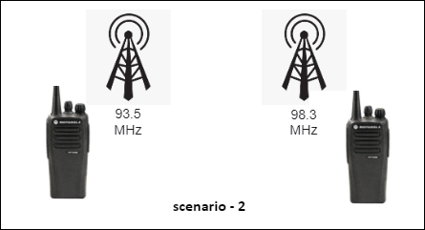

Figure 1.11 Scenario 5

2) Refer to the following diagram and identify which type of communication is done.

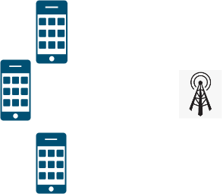

Figure 1.12 Scenario 5

ans:

3) Refer to the following diagram and identify which type of communication is done.

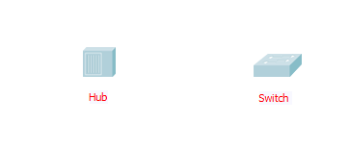

Figure 1.13 Scenario 5

4) Refer to the following diagram, figure 1.14, and identify which type of communication is done.

Different radio stations in different cities and they are communicating to each other so which type of communication is happen between this radio stations.

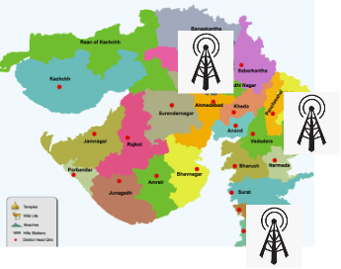

Figure 1.14 Scenario 5

5) Refer to the following diagram and identify which type of communication is done.

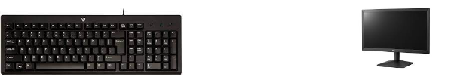

Figure 1.15 Scenario 5

6) Refer to the following diagram and identify which type of communication is done.

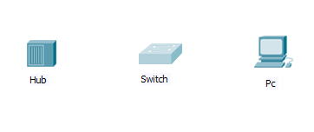

Figure 1.16 Scenario 5

# Study the different types of Cables in Networking and based on that perform the following case study.

# Refer to the following link.

# https://fcit.usf.edu/network/chap4/chap4.htm

# When it comes to connecting the networks, we can connect them in two different ways

# Wired Connection

# Wireless connection

**Different types of Networking Cables:**

1. Unshielded Twisted Pair (UTP) Cable
2. Shielded Twisted Pair (STP) Cable
3. Coaxial Cable
4. Fiber Optic Cable
5. Cable Installation Guides
6. Wireless LANs
7. Unshielded Twisted Pair (UTP) Cable

**Case Study:**

1) Refer to the following Linear Bus Topology and make the connection using appropriate cables.

Link: https://fcit.usf.edu/network/chap5/chap5.htm

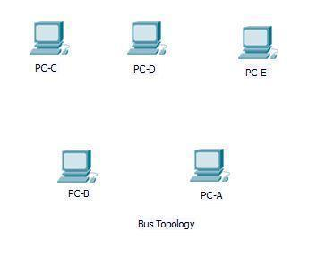

Figure 1.17 Scenario 5

2) Refer to the following Star Topology and make the connection using appropriate cables.  
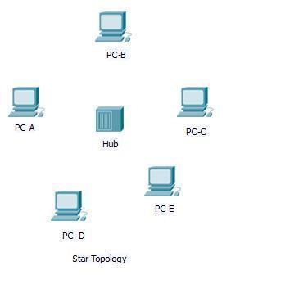

Figure 1.18 Scenario 5

3) Refer to the following Tree Topology and make the connection using appropriate cables.

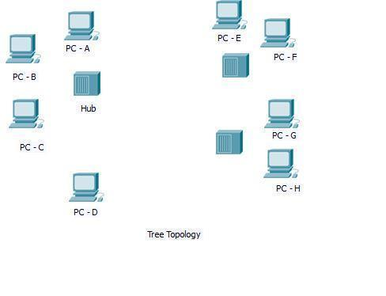

Figure 1.19 Scenario 5

Refer to the following Network Diagram - Typical Simple Home Network

# https://fcit.usf.edu/network/chap4/chap4.htm

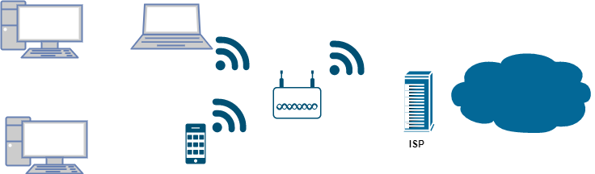

Figure 1.20 Scenario 5

**Refer to the following images and based on that let’s understand the concept of Multiplexing and Demultiplexing.**

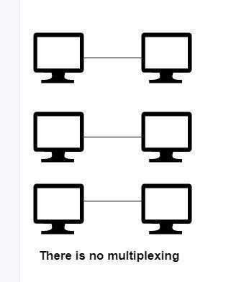

Figure 1.21 Scenario 5

In above point to point topology, all the nodes can send and receive data but with their own channels. so required three own channels.

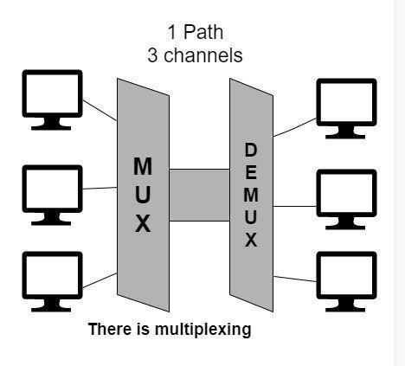

Figure 1.22 Scenario 5

In the above diagram, With the help of multiplexing, more than one signal can be sent easily over a single medium or link. Multiplexing helps in the effective utilization of the bandwidth of the medium.

**Questions**

Students are advised to give answers to following questions after going through in-depth study of all above references:

1. What is the significance of Braided Shield in Shielded Twisted Pair (STP) cable?

Answer:

1. List down various network cables in markets other than UTP and STP.

Answer:

3. Where UTP and STP cables are used?

Answer:

4. List down the four parameters, on which the UTP cables are categorised.

Answer:

5. What is the difference in pin architecture of Cross-over cable and straight through cable?

Answer:

6. Why is twisted pair used in network cable?

Answer:

7. Why do we require two wires for signal transmission in cable and one wire in optic transmission in fibre optic?

Answer:

8. Write down in 2nd column (which cable to use) below:

|  |  |
| --- | --- |
| **Connection Scenario** | **Cable Type**  **(Cross Over or straight Through)** |
| Computer to Computer |  |
| Cable modem to Router |  |
| Computer to Cable modem |  |
| Computer to Switch |  |
| Computer to Hub |  |

9. What is the full form of RJ-45?

Answer:

10. List down various RJ connectors with their usage.

Answer:

11. What signal is used for wireline, wireless and fibre communication? Give example how data is transmitted in simplex, half-duplex and full duplex communication with respect to above cables.

Answer:

12. What are tools used to make network cable with CAT-6 cable? Also write its usage.

Answer:

13. Mention the companies who are making the cables.

Answer:

14. What is delay and loss in the network?

Answer:

15. How long does a 10Mbps channel take to transmit 1 bit ?

16. Mention the companies who are making the following specific cables.

|  |  |
| --- | --- |
| **Name of the Cables** | **Companies who are making the cables.** |
| Unshielded Twisted Pair (UTP) Cable |  |
| Shielded Twisted Pair (STP) Cable |  |
| Coaxial Cable |  |
| Fiber Optic Cable |  |

**Gate Question:**

1. **Calculate the number of cables used for 4 Nodes in mesh topology ?**

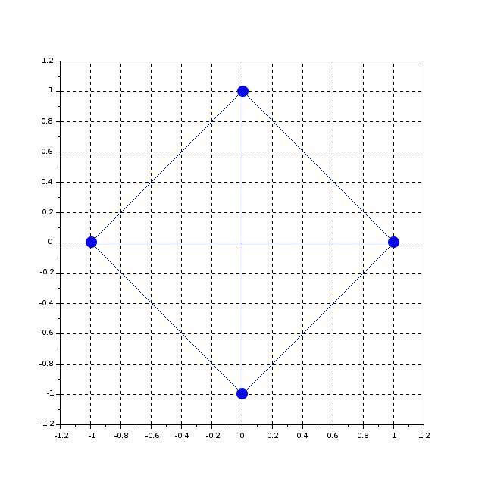

1. **Calculate the number of cables used for 16 Nodes in mesh topology ?**

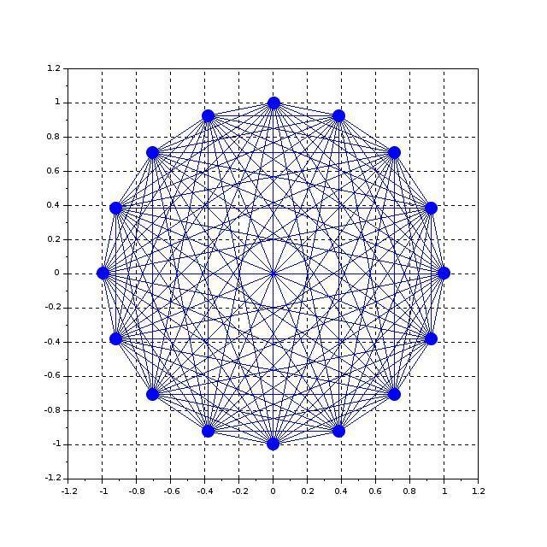

1. **In a fully-connected mesh network with 10 computers, a total ______ number of cables are required and ______ number of ports are required for each device.**

**[UGC-NET | UGC NET CS 2016 July]**

1. 40,9
2. 45,10
3. 45,9
4. 50,10
5. **Determine the maximum length of the cable (in km) for transmitting data at a rate of 500 Mbps in an Ethernet LAN with frames of size 10,000 bits. Assume the signal speed in the cable to be 2,00,000 km/s. [GATE | GATE CS 2013]**
6. 1
7. 2
8. 2.5
9. 5
10. **Consider a source computer transmitting a file of size 106 bits to a destination computer (D) over a network of two routers (R1 and R2) and three links (L1, L2 and L3). L1 connects to S to R1; L2 connects to R1 to R2; and L3 connects to R2 to D. Let each link be of length 100 km. Assume signals travel over each link at a speed of 108 meters per second. Assume that the link bandwidth on each link is 1Mbps. Let the file be broken down into 1000 packets each of size 1000 bits. Find the total sum of transmission and propagation delays in transmitting the file from S to D?**
11. 1005 ms
12. 1010 ms
13. 3000 ms
14. 3003 ms
15. **Let us consider a statistical time division multiplexing of packets. The number of sources is 10. In a time unit, a source transmits a packet of 1000 bits. The number of sources sending data for the first 20 time units is 6, 9, 3, 7, 2, 2, 2, 3, 4, 6, 1, 10, 7, 5, 8, 3, 6, 2, 9, 5 respectively. The output capacity of multiplexer is 5000 bits per time unit. Then the average number of backlogged of packets per time unit during the given period is**
16. 5
17. 4.45
18. 3.45
19. 0
20. **A broadcast channel has 10 nodes and total capacity of 10 Mbps. It uses polling for medium access. Once a node finishes transmission, there is a polling delay of 80 μs to poll the next node. Whenever a node is polled, it is allowed to transmit a maximum of 1000 bytes. The maximum throughput of the broadcast channel is:**
21. 1 Mbps
22. 100/11 Mbps
23. 10 Mbps
24. 100 Mbps

1. **Consider a CSMA/CD network that transmits data at a rate of 100 Mbps (108 bits per second) over a 1 km (kilometre) cable with no repeaters. If the minimum frame size required for this network is 1250 bytes, What is the signal speed (km/sec) in the cable?**
2. 8000
3. 10000
4. 16000
5. 20000
6. **A network has a data transmission bandwidth of 20 × 106 bits per second. It uses CSMA/CD in the MAC layer. The maximum signal propagation time from one node to another node is 40 microseconds. The minimum size of a frame in the network is _____________________bytes.**
7. **Which of the following statements is TRUE about CSMA/CD:**
8. IEEE 802.11 wireless LAN runs CSMA/CD protocol
9. Ethernet is not based on CSMA/CD protocol
10. CSMA/CD is not suitable for a high propagation delay network like satellite network
11. **A network with CSMA/CD protocol in the MAC layer is running at 1Gbps over a 1km cable with no repeaters. The signal speed in the cable is 2 × 108m/sec . The minimum frame size for this network should be:**
12. 10000bits
13. 10000bytes
14. 5000 bits
15. 5000bytes
16. **Determine the maximum length of the cable (in km) for transmitting data at a rate of 500 Mbps in an Ethernet LAN with frames of size 10, 000 bits. Assume the signal speed in the cable to be 2, 00, 000 km/s.**
17. 1
18. 2
19. 2.5
20. 5
21. **In an Ethernet local area network, which one of the following statements is TRUE?**
22. A station stops to sense the channel once it starts transmitting a frame.
23. The purpose of the jamming signal is to pad the frames that are smaller than the minimum frame size.
24. A station continues to transmit the packet even after the collision is detected.
25. The exponential back off mechanism reduces the probability of collision on retransmissions.
26. **Consider two hosts X and Y , connected by a single direct link of rate 106 bits/sec. The distance between the two hosts is 10, 000 km and the propagation speed along the link is 2 × 108 m/sec . Host X sends a file of 50, 000 bytes as one large message to host Y continuously. Let the transmission and propagation delays be p milliseconds and q milliseconds respectively. Then the value of p and q are**
27. p = 50 and q = 100
28. p = 50 and q = 400
29. p = 100 and q = 50
30. p = 400 and q = 50
31. **Consider the store and forward packet switched network given below. Assume that the bandwidth of each link is 106 bytes /sec. A user on host A sends a file of size 103 bytes to host B through routers R1 and R2 in three different ways. In the first case a single packet containing the complete file is transmitted from A to B. In the second case, the file is split into 10 equal parts, and these packets are transmitted from A to B. In the third case, the file is split into 20 equal parts and these packets are sent from A to B. Each packet contains 100 bytes of header information along with the user data. Consider only transmission time and ignore processing, queuing and propagation delays. Also assume that there are no errors during transmission. Let T 1, T 2 and T 3 be the times taken to transmit the file in the first, second and third case respectively. Which one of the following is CORRECT?**

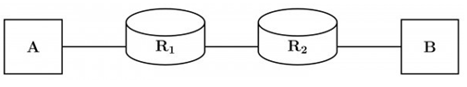

1. T 1 < T 2 < T 3
2. T 1 > T 2 > T 3
3. T 2 = T 3, T 3 < T 1
4. T 1 = T 3, T 3 > T 2
5. **Two hosts are connected via a packet switch with 107 bits per second links. Each link has a propagation delay of 20 microseconds. The switch begins forwarding a packet 35 microseconds after it receives the same. If 10000 bits of data are to be transmitted between the two hosts using a packet size of 5000 bits, the time elapsed between the transmission of the first bit of data and the reception of the last bit of the data in microseconds is ____________.**
6. **Frames of 1000 bits are sent over a 106 bps duplex link between two hosts. The propagation time is 25 ms. Frames are to be transmitted into this link to maximally pack them in transit (within the link).**

**What is the minimum number of bits (I) that will be required to represent the sequence numbers distinctly? Assume that no time gap needs to be given between transmission of two frames.**

1. I = 2
2. I = 3
3. I = 4
4. I = 5
5. **A channel has a bit rate of 4 kbps and one-way propagation delay of 20 ms. The channel uses stop and wait protocol. The transmission time of the acknowledgment frame is negligible. To get a channel efficiency of at least 50%, the minimum frame size should be**
6. 80 bytes
7. 80 bits
8. 160 bytes
9. 160 bits